**What is Inheritance?**

Inheritance is one of the core principles of Object Oriented Programming (OOP). It allows one class (called the *child* or *subclass*) to inherit attributes and behaviours (fields and methods) from another class (called the *parent* or *superclass*). This helps avoid repetition and keeps code organized. Instead of writing the same code in multiple places, we can just write it once in a base class and let other classes use it.

**Benefits of Inheritance:**

One major benefit of inheritance is that it promotes code reusability. If multiple classes share common behaviour, you can define that behaviour in a base class. This makes the code easier to maintain because changes to shared behaviour only need to be made in one place. Also, it helps with readability, developers can look at a class and understand what it does by seeing what it inherits from.

**Application of Inheritance:**

In my recent assignment, I built a simple program where I had a base class called Activity, and then three child classes: BreathingActivity, ReflectionActivity, and ListingActivity. Each of the child classes inherited shared methods like DisplayStartMessage() and DisplayEndMessage() from the base Activity class, while also having their own unique methods.

**Code Example:**

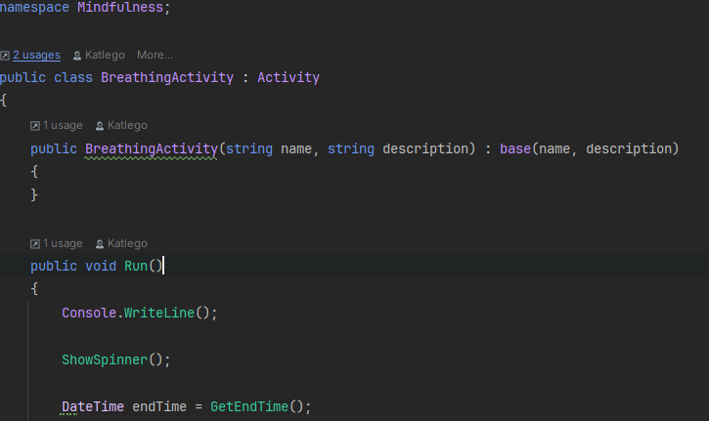

Both ShowSpinner() and GetEndTime() are methods inherited from the base class: Activity.

In this example, I’m also calling the base class constructor with two arguments—(name, description)